# BAN5573 - Visual Analytics and Business Intelligence

# Final Project

Team members: Yuanyuan Bai, Preetika Babu

1. **Introduction**
   1. **Motivation:**

Vaccination is an important part of preventing communicable diseases; nonetheless, vaccinations have always been associated with public dread and mistrust, and the COVID-19 vaccine is no exception. The usage of social media has been linked to a poor level of vaccination acceptability.

* 1. **Problem Statement:**

Our project mainly involves the sentimental analysis of the Covid vaccines and how they have an impact on the humans in terms of a positive or negative manner.

* 1. **Research Questions**

1. Analyzing the tweets related to covid 19 vaccine.
2. Analyzing the user with highest number of retweets
3. Predict the change in mood levels for mood deterioration and mood improvement
4. The perspective on evolution of vaccine opinions across countries.
   1. **Project Scope:**

Although public health initiatives have shown to be somewhat effective in slowing the spread of COVID-19, vaccination's protective and long-lasting immunity will be vital in bringing the pandemic to an end. It is estimated that at least 70% of the population will need to be vaccinated in order to attain any level of herd immunity. Immunization support from the general population is crucial to reaching this aim. As a result, knowing what the general population thinks about vaccination and, as a result, their desire to be vaccinated, is crucial.

1. **Data**
   1. **Data Source**

**Source: Kaggle**

[**https://www.kaggle.com/gpreda/all-covid19-vaccines-tweets?select=vaccination_all_tweets.csv**](https://www.kaggle.com/gpreda/all-covid19-vaccines-tweets?select=vaccination_all_tweets.csv)

* 1. **Data Description:**

|  |  |
| --- | --- |
| ID | Identification number for each user. |
| user_name | Name of the user |
| User_location | Location of the user |
| User_followers | No of followers the user has |
| User_friends | No of friends the user has |
| User_favorites | No of users in favor for the user’s tweet |
| User_verified | If the user is verified or not |
| Date | The date the tweet was posted |
| Text | Tweet content |
| Hashtags | Type of hashtags used in the tweet |
| Source | Source of the tweet |
| Retweets | No of retweets |
| Is_retweets | Whether the tweet is retweeted or not |
| Favorites | No of users who are in favor with the tweet |

1. **Descriptive Statistics & Data Visualizations:**
   1. Analyzing the tweets related to covid 19 vaccine in the years 2020 and 2021.

* 1. Analyzing the tweet with highest number of retweets

* 1. Predict the change in mood levels for mood deterioration and mood improvement  
     Timeline

     Description automatically generated

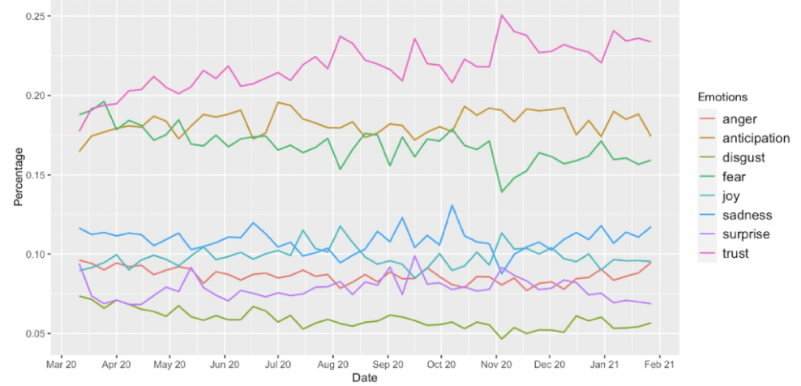

### Screen Shot 2021-10-23 at 11.00.08 PM

Average characteristics of Twitter users across vaccine opinions.

### Screen Shot 2021-10-23 at 11.30.20 PM

Other visualizations

1. **Conclusion:**

This notebook examines the sentiment expressed in Twitter about the covid19 immunization campaign. We can observe the impact of widespread rumors, which resulted in a negative attitude at the start of the vaccine campaign. The vaccination campaign, on the other hand, is in full swing all over the world, thanks to clear confirmation of the vaccines' efficacy. We also noticed that a country's internal affairs have a substantial impact on tweet sentiment. We hope that this vaccine effort is a success, and that in the coming months, we will see a jump in public opinion.

1. **Business suggestion**

COVID-19 is a persistent global issue, and the vaccination argument is also global. The virus outbreak has shown how interconnected the world has become, and vaccination has thus become a global problem. If a country cannot achieve a specific level of vaccination among its citizens, it faces a significant risk of disruption and virus mutation; as a result, it will be difficult for the country to reclaim its positions in the international economy, and global cooperation will be required to overcome the deadly virus. As a result, the economic consequences of the pandemic, as well as vaccine research, are critical concerns [33-35]. The current study included sentiment and opinion analysis of large amounts of COVID-19 vaccine-related tweets. The Twitter interface used in this study could be a useful strategy for increasing public health awareness and increasing vaccine acceptance while decreasing vaccine hesitancy and resistance. Finally, analyzing vaccination attitudes and perspectives might help public health workers reinforce sound judgment and statements in positive posts while rejecting forceful language that spreads erroneous information in negative ones. Additionally, public health authorities may be prepared to use Twitter and other social media platforms to spread positive messages.

**6. Literature Review**

1.<https://www.kaggle.com/hassanhshah/covid-vaccine-sentiment-and-time-series-analysis/notebook>

2.<https://towardsdatascience.com/sentiment-analysis-of-covid-19-vaccine-tweets-dc6f41a5e1af>

3.<https://papers.ssrn.com/sol3/papers.cfm?abstract_id=3869531>

4.<https://public.tableau.com/app/profile/william8331/viz/twitter-world-sentiment-analysis-2/WorldSentiment>

5.<https://www.ijidonline.com/article/S1201-9712(21)00462-8/pdf>